WDW-HLT Computer control high and low temperature electromechanical tensile testing machines( -70℃～350℃)

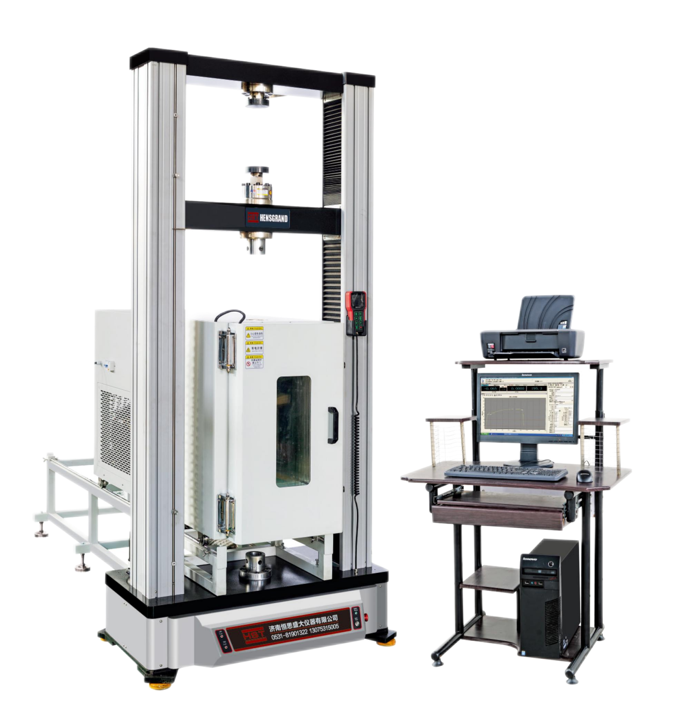

Application
This series testing machines is mainly suitable for rubber, plastic profile, plastic pipe, sheet, sheet, film, wire and cable, waterproof coil, wire and othermaterials in high temperature or low temperature environment, tensile, compression, bending, peeling, tearing, shear and other mechanical properties of the test; It is very convenient for users to carry out research and development, quality control work, and is an ideal testing instrument for industrial and mining enterprises, commodity inspection arbitration, scientific research units, colleges and universities, engineering quality departments.
Specifications
MODEL | HST-10EGD | HST-20EGD | HST-30EGD | HST-50EGD
Load Capacity (kN) | 10 | 20 | 30 | 50
Load accuracy | Class 0.5
Testing Load Accuracy | ±0.5%
Testing Load Range(FS) | 0.2%-100%
Load Resolution | 1/500,000FS
Resolution of displacement(μm) | 0.04
Crosshead speed range(mm/min)  (mm/min) | 0.001-1000
Crosshead speed accuracy | ±0.5% of set speed
Crosshead Travel(mm) | 1100
Room temperature Tensile Space(mm) | 770  650
Room temperature Compression Space(mm) | 1000
Room temperature Test width (mm) | 450
Operating temperature range | -40℃/-60℃/-70℃ -350℃( according to customer's order)
Cooling system | compressor
Power | AC220V±10%, 50Hzcan be customized)

